

***C# BASICS***

**Training Assignments**

| **Document Code** | **25e-BM/HR/HDCV/FSOFT** |
| --- | --- |
| **Version** | **1.1** |
| **Effective Date** | **20/11/2012** |

**Hanoi, 06/2019**

**RECORD OF CHANGES**

| **No** | **Effective Date** | **Change Description** | **Reason** | **Reviewer** | **Approver** |
| --- | --- | --- | --- | --- | --- |
|  | 01/Oct/2018 | Create new | Draft |  |  |
|  | 01/Jun/2019 | Update template | Fsoft template | DieuNT1 |  |
|  |  |  |  |  |  |
|  |  |  |  |  |  |
|  |  |  |  |  |  |
|  |  |  |  |  |  |
|  |  |  |  |  |  |
|  |  |  |  |  |  |
|  |  |  |  |  |  |
|  |  |  |  |  |  |

**Contents**

Day 4: Assignment 12: Named and Optional Arguments 4

Objectives: 4

Business needs: 4

Prerequisites: 4

Technologies: 4

IO: 4

1. Exercise 1: 5

2. Exercise 2: 5

3. Exercise 3: 5

4. Exercise 4: 5

5. Exercise 5: 6

|  | **CODE: Net.M.A012**  **TYPE: MEDIUM**  **LOC: 190**  **DURATION: 180 MINUTES** |
| --- | --- |

# Day 4: Assignment 12: Named and Optional Arguments

**Objectives:**

* Understand and practice Optional Arguments and Named Arguments.

**Business needs:**

* TBD

**Prerequisites:**

* Working environment: Visual Studio 2013 or higher.Practice code in Visual Studio
* Each exercise is one project inside 1 solution.

**Technologies:**

The product implements one or more technology:

* Optional Arguments
* Named Arguments
* C# basic

**IO:**

* Console windows

1. **Exercise 1:**

Build Student class with the following properties:

* Name: string
* Class: string.
* Gender: string.
* Gender: string.
* Relationship: string.
* EntryDate: Date.
* Age: int.
* Address: string.
* Mark: decimal.
* Grade: string.

1. **Exercise 2:**

Build the constructor using the Optional Arguments as follows:

* Relationship giá trị mặc định là Single
* EntryDate: the default value is the current date
* Mark: default value is 0.
* Grade: default value is F

1. **Exercise 3:**

The build metho d uses the Optional Arguments as follows:

Graduate method construction has parameter of gradePoint, default value is 0.

Set value for Grade according to the table below:

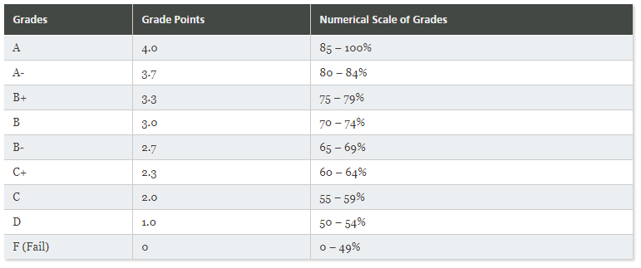

1. **Exercise 4:**

Constructing the ToString () method with a parameter that formatString contains the fields to write, the default value is "name, grade". Returns the formatted string of information based on the passed parameter.

1. **Exercise 5:**

Perform Student object initialization, using Optional Arguments, Named Arguments.

Implement the Graduate method call in both cases: there is transmission parameter, no parameter transmission.

The implementation calls the ToString method in both cases: there is a transmission parameter, no parameter transmission.

Commenting on the benefits of using Optional Arguments, Named Arguments.

Note the rules when using Optional Arguments, Named Arguments.